**KDM :ICP 12**

**Name: Aravind Yanamala**

**Student id:16315604**

Here I imported all required libraries.

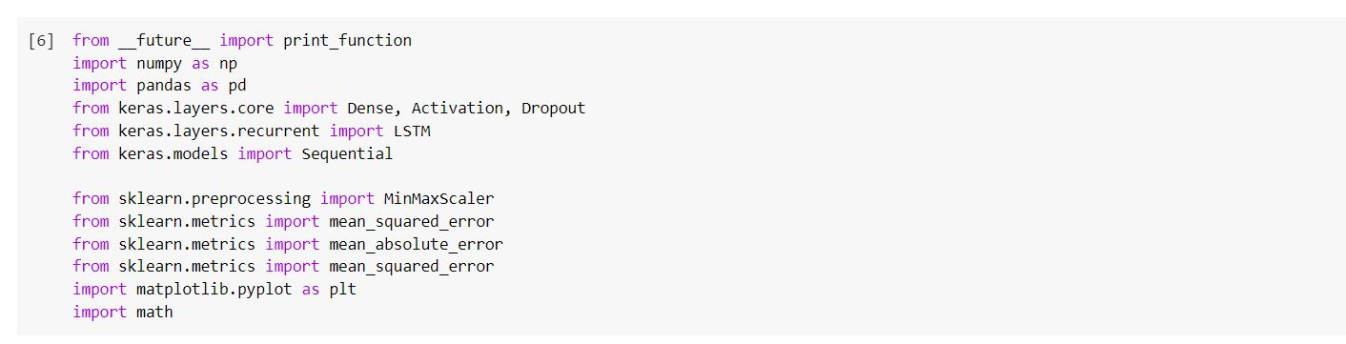

I took look-back=7 and batch-size=32 for to predict the best model.

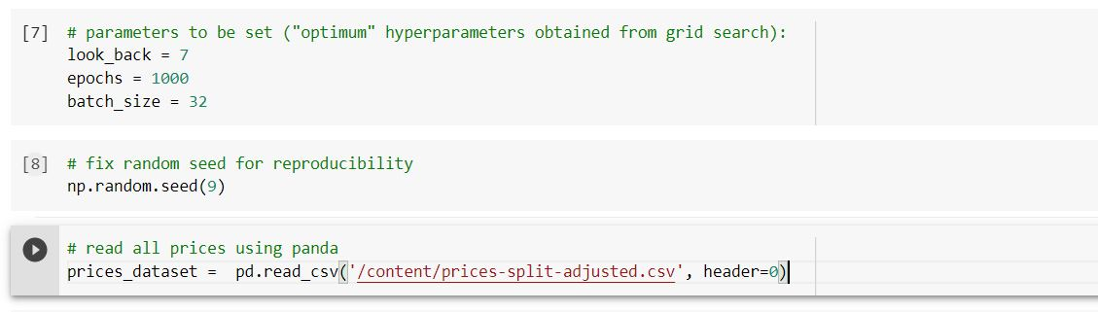

I took Apple dataset.

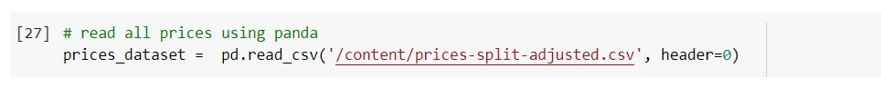

Some of the few companies data in stoke market shows i.e volume weather it is low or high.

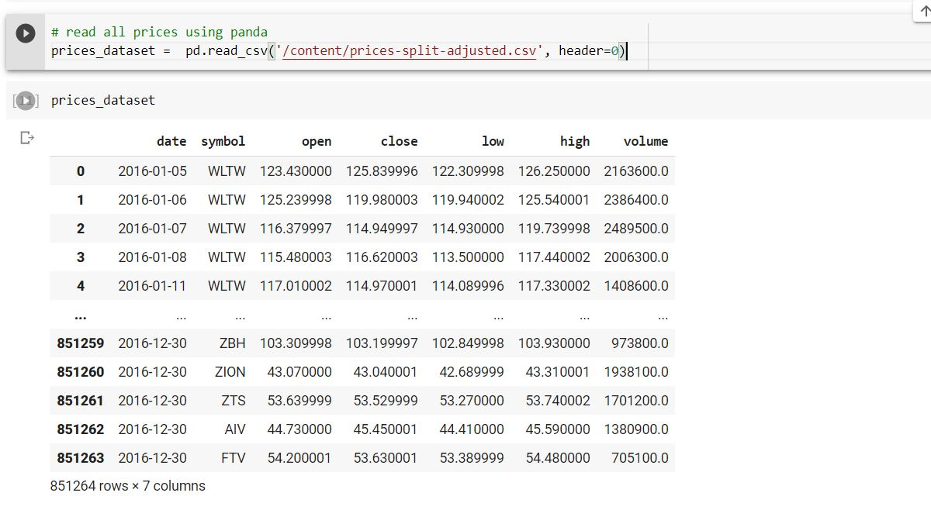

I took only Apple model which is represented with AAPL.

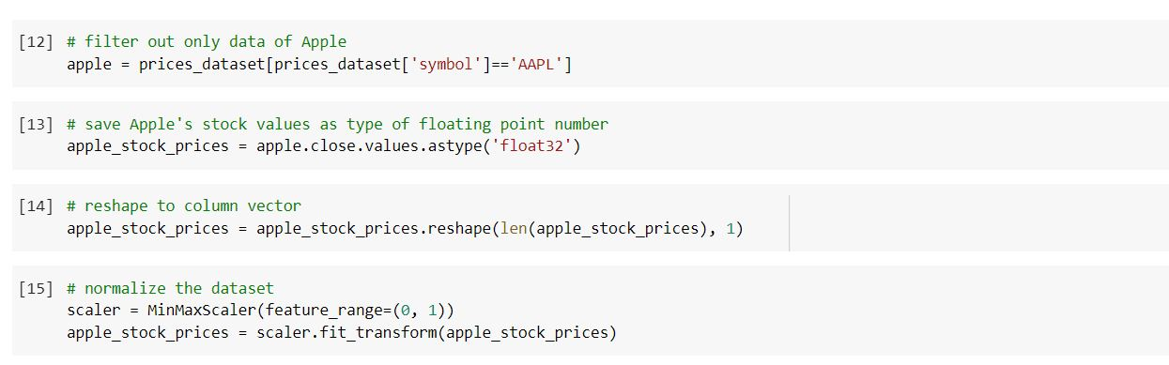

I took stoke price of the Apple. I divided the dataset for training and testing. 60% for training and 40% for testing . After splitting the data no.of training samples are 1180 and testing samples are 582.

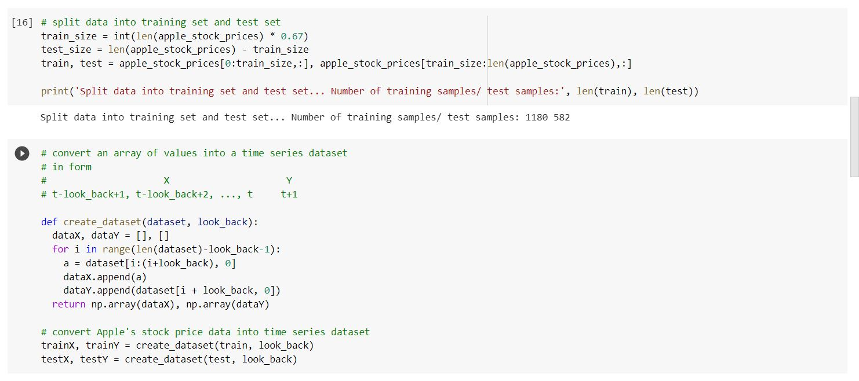

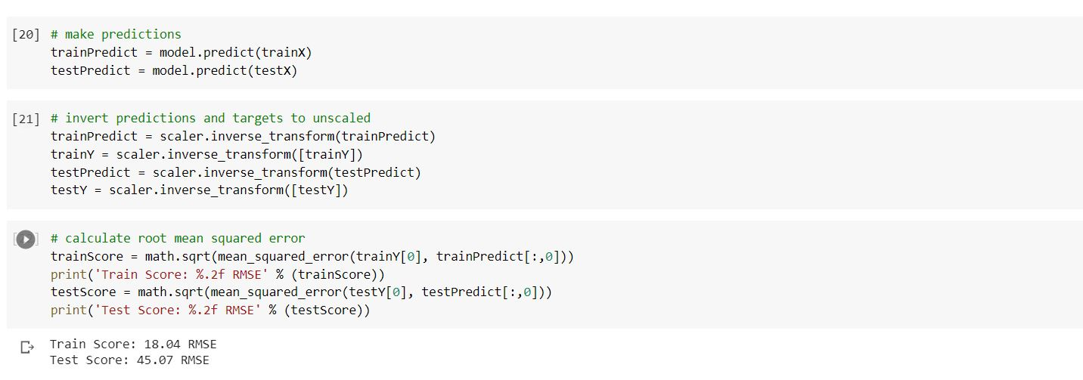

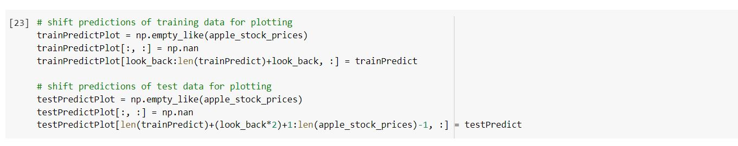

In the graph blue line represented the train predict graph and red,green graph represent the test predict graph between the apple stoke prices.

